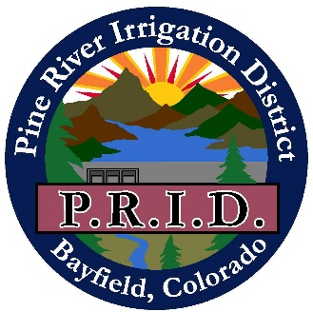

Vallecito Reservoir
Draft Recreation Management Plan
Prepared by the Pine River Irrigation District in cooperation with the Bureau of Reclamation Western Colorado Area Office

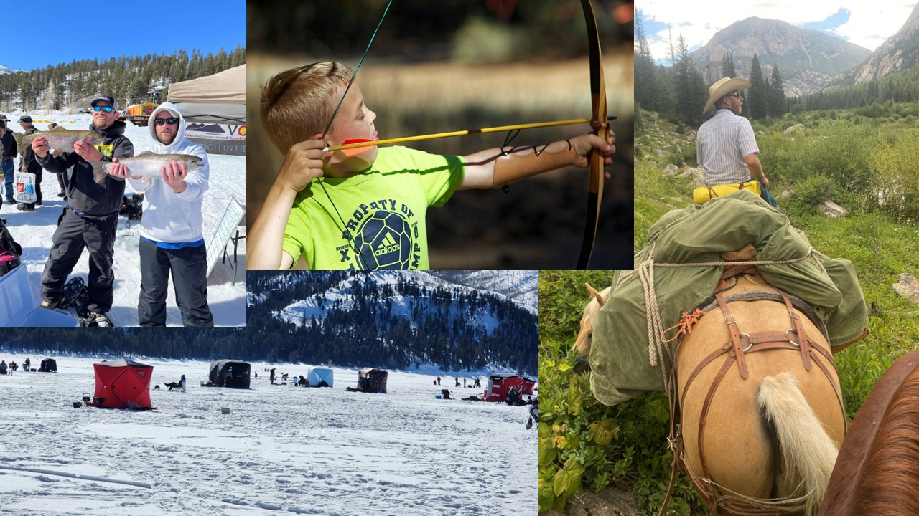
Photo 1. Example Recreation Activities at Vallecito Reservoir
Table of Contents
1. Purpose 4
2. Mission Statement 4
3. Agency Roles and Responsibilities 4
3.1. PRID (Non-Federal Recreation Manager/Partner) 4
3.2. Reclamation 4
3.3. USFS 5
4. Management Authorities and Recreation Agreements 5
5. Definitions 6
6. PRP History 9
7. Recreation at Vallecito Reservoir 9
7.1. Early Recreation 10
7.2. Current Recreation 12
7.3. Planned Recreation 14
8. Permits and Fees 14
8.1. Permits 14
8.2. Fees 15
8.3. Establishing Fee Pricing Levels for the Recreation Permits 16
9. Rules and Regulations 16
10. Policies, Practices, and Procedures 19
10.1. Hours of Operation 20
10.2. Closures (Emergency, Seasonal, etc.) 20
10.3. AIS/ANS Inspection and Decontamination Procedures 20
10.4. Regulation of Vallecito Reservoir Water Elevations and Impacts on Recreation 20
10.5. Marina and Vallecito Reservoir Recreation Program Sustainability 21
10.6. Length of Time of Recreation Concession Contracts 21
10.7. Annual Meetings 21
10.8. Law Enforcement 21
11. Website Links 21

Table of Figures, Maps, and Photos
Figure 1. Pine River Project Recreational Amenities at Vallecito Reservoir 3
Figure 2. Fred Klatt with trophy trout from Vallecito Reservoir in 1945 11

Acronyms
AIS Aquatic invasive species
ANS Aquatic nuisance species
CPW Colorado Parks and Wildlife
Plan Recreation Management Plan
PRID Pine River Irrigation District
PRP Pine River Project
Reclamation United States Department of the Interior, Bureau of Reclamation
USFS United States Forest Service
VCSA Vallecito Conservation and Sporting Association
VMYC Vallecito Marina and Yacht Club (subsidiary of VCSA)
VNC Vallecito Nordic Club
CFR Code of Federal Regulations

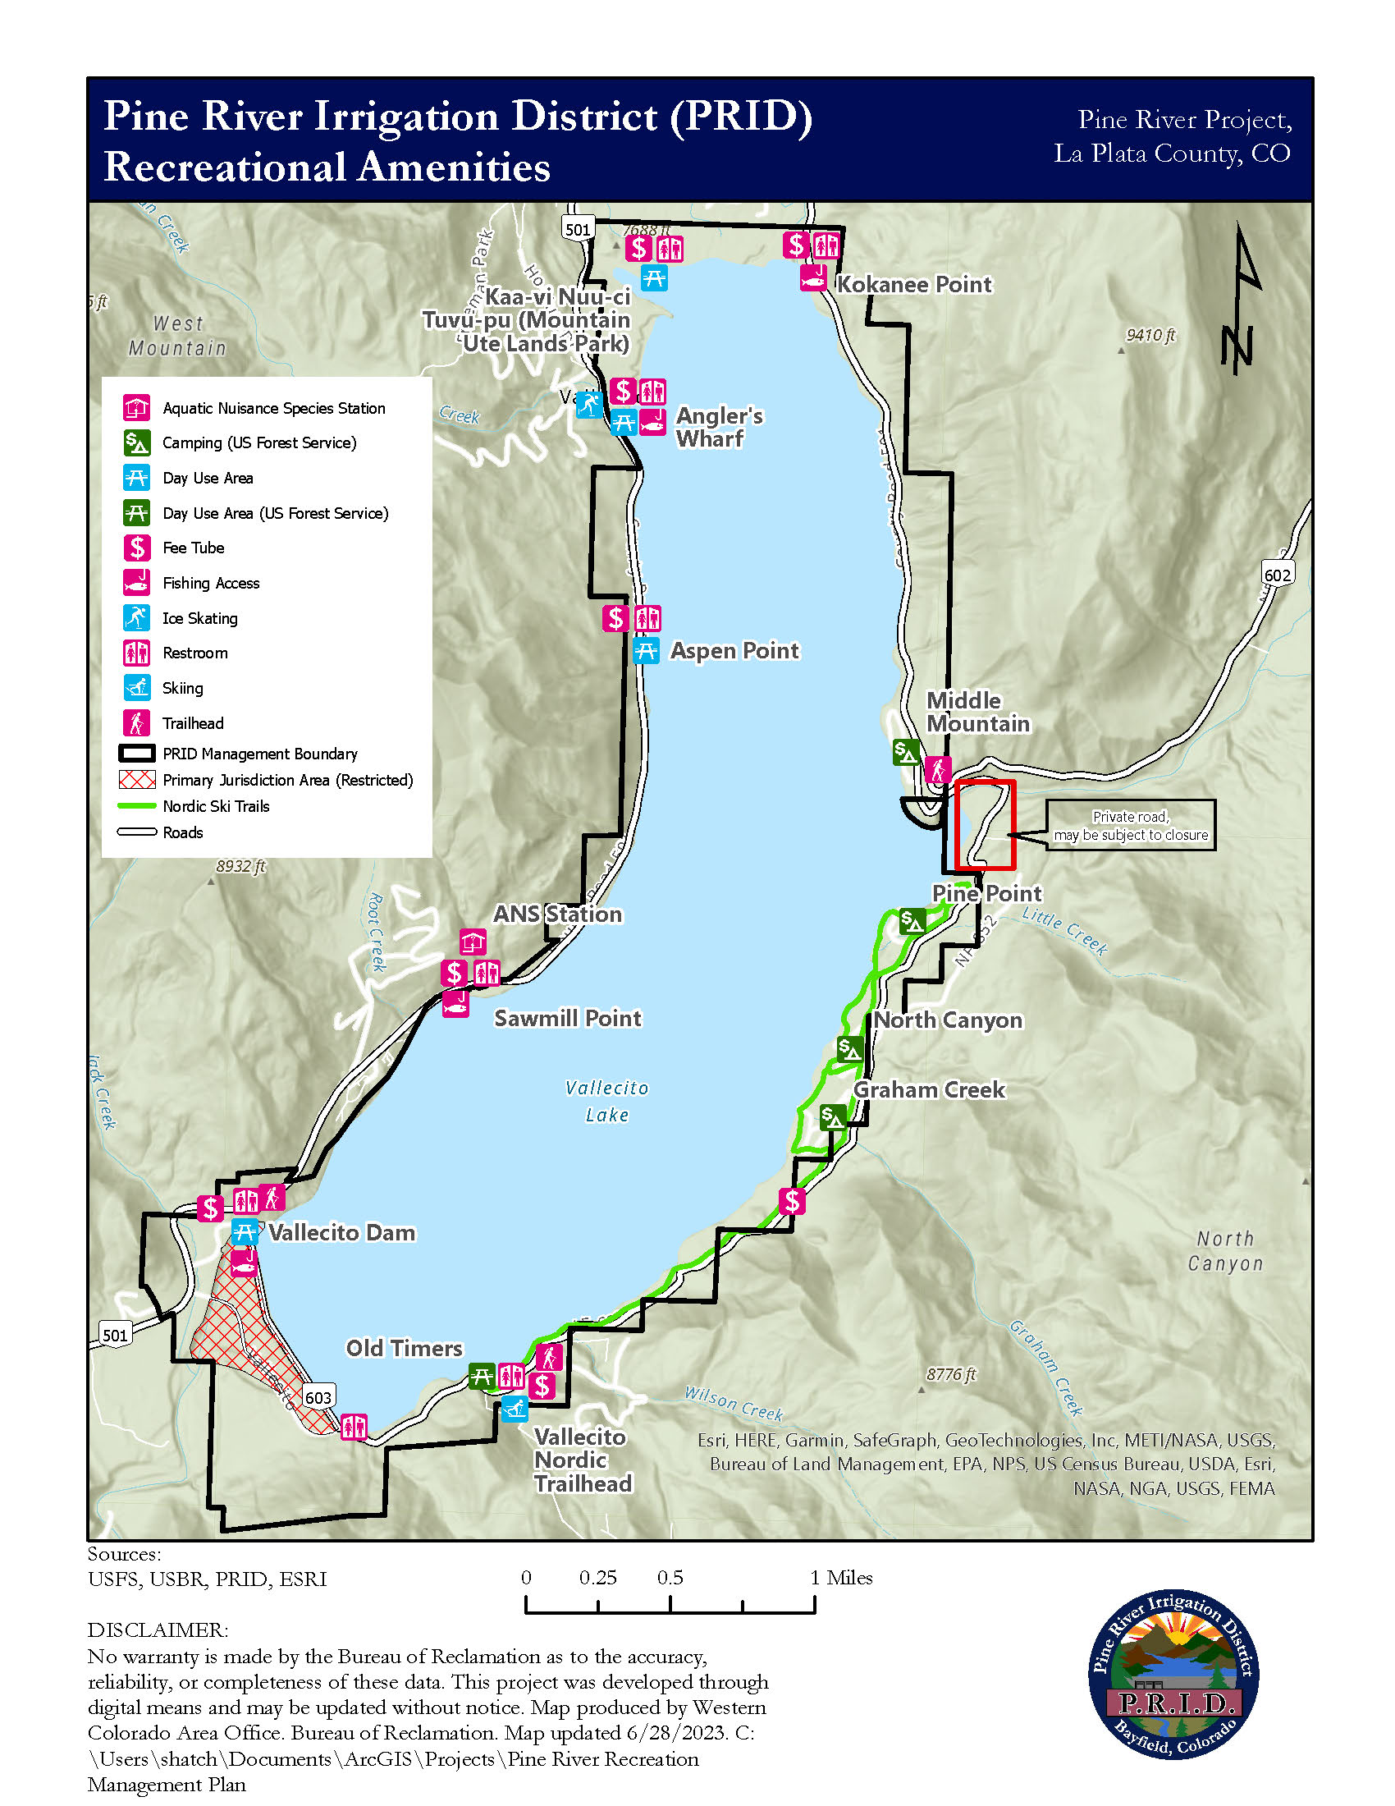
Figure 1. Pine River Project Recreational Amenities at Vallecito Reservoir

Purpose
The purpose of this Vallecito Reservoir Draft Recreation Management Plan (Plan) is to provide the public information on the management philosophy, requirements, and restrictions used by the Pine River Irrigation District (PRID) to manage and oversee recreation activities at the U.S. Bureau of Reclamation’s (Reclamation) Pine River Project (PRP), specifically at Vallecito Reservoir. PRID’s objective is to maximize recreation opportunities for the public and continue to develop and refine a self-sustaining and quality recreation program at Vallecito Reservoir. This Plan is a living document and is subject to change as PRID seeks public input and implements future improvements at the reservoir.

Mission Statement
PRID’s mission is to operate, maintain, and manage Vallecito Dam, Reservoir, and Power Plant in an environmentally conscious, safe, efficient, and cost-effective manner to provide supplemental irrigation water to 65,000 acres of Native American and non-Native American lands, provide water and power for domestic users, and manage recreation activities for the protection of the resource and the enjoyment of the public. PRID will conduct work activities with the highest degree of integrity and transparency.

Agency Roles and Responsibilities
PRID, Reclamation, and the United States Forest Service (USFS) share in the responsibility of managing lands and recreation at and adjacent to Vallecito Reservoir which is described further below.

PRID (Non-Federal Recreation Manager/Partner)
Pursuant to long-term contracts with Reclamation (described in Chapter 4), PRID is responsible for the repayment and operation and maintenance of the PRP as well as the development, administration, operation, and maintenance of recreation at Vallecito Reservoir. More information about PRID can be found at the PRID website (see Section 11).

Reclamation
The PRP is a Federally constructed project. Reclamation has ownership and administrative responsibility over the PRP which may include periodic planning, development, administration, operation, maintenance, and replacement activities for the PRP. Per the authorities in Public Law 89-72, as amended, Reclamation has entered into agreements with PRID to be the recreation managing partner at Vallecito Reservoir. Reclamation helps guide and oversee the PRP recreation program while also leading environmental and cultural resource compliance and general land management efforts at the PRP. Reclamation retains primary jurisdiction for the area surrounding Vallecito Dam, its appurtenant facilities, and the vicinity below the dam (Primary Jurisdiction Area) which is closed to the public.

USFS
The USFS has jurisdictional responsibility for all National Forest System lands within the PRP boundary which include the Middle Mountain, Pine Point, North Canyon, and Graham Creek Campgrounds as well as the Old Timers Day Use Area located on the south and east sides of Vallecito Reservoir and outside of Reclamation’s Primary Jurisdiction Area. Several USFS grazing allotments are adjacent to Vallecito Reservoir and grazing periodically occurs at Vallecito Reservoir under USFS management. The USFS is involved with managing cross-country skiing at the southern end of the reservoir.

Management Authorities and Recreation Agreements
PRID’s management of the PRP and recreation agreements at Vallecito Reservoir are governed by the following laws, authorities, contracts, agreements, and planning documents.
- Laws
  - Public Law 89-72 (Federal Water Project Recreation Act of 1965, as Amended)
    - Gives Reclamation authority to enter into management agreements for managing recreation and fish and wildlife enhancement facilities with non-Federal and Federal partners as well as share in the cost of planning, developing, and maintaining recreation at said facilities.
- Contracts
  - 1953 PRP Amendatory Repayment Contract
    - Amendatory contract between the United States of America and PRID which identifies the reimbursable costs of the construction of the PRP, under the Federal Reclamation Laws, to be repaid by PRID.
      - Regarding revenue, Article 30 of this contract states: “During any period when the District is operating the project works all revenues derived from land and property required for operation and maintenance of the project works, including revenues from boating and other uses, shall become the property of the District and the Bureau of Indian Affairs for application, five-sixths and one-sixth, respectively, on the annual cost of the operation and maintenance of such works.”
  - 1984 Vallecito Reservoir Recreation Memorandum of Agreement (as amended and extended)
    - Memorandum of Agreement between PRID and Reclamation for the development, administration, operation, and maintenance of water-based recreation at Vallecito Reservoir.
      - Regarding revenue, Article 14 of this contract states: “Revenues as referred to in this article shall mean receipts from user fees charged by the DISTRICT within the reservoir area. The DISTRICT shall account for all revenues and expenditures. All receipts pertaining specifically to Vallecito Reservoir water-based recreation shall be used only for the administration, development, maintenance, and replacement costs associated with recreation management of the reservoir area.”
- Planning Documents
  - 1996 Vallecito Reservoir Resource Management Plan
    - This plan provides a formal program and set of policy guidelines necessary to encourage orderly and organized use, development, and management of Vallecito Reservoir and surrounding Reclamation lands.
- Agreements
  - 2021 Project Supplemental Agreement between the Department of Agriculture, United States Forest Service, San Juan National Forest and the Department of the Interior, Bureau of Reclamation Regarding the Administration of Pine River Project and National Forest System Lands and Forest Service Recreation Facilities In and Surrounding Vallecito Reservoir, Pine River Project, Colorado
    - Supplemental agreement between the USFS and Reclamation on jurisdictional authority and management of adjacent areas near Vallecito Reservoir. USFS administration of several campgrounds and a day use area within the PRP began in 1978 after transfer from Reclamation.
PRID observes the below Codes of Federal Regulations (CFRs) related to Reclamation and recreation use and management at Vallecito Reservoir. For the public’s convenience, copies of these CFRs are available for review online or at the PRID website (see Section 11).
- 43 CFR Part 420 (Off-Road Vehicle Use);
- 43 CFR Part 423 (Public Conduct On Bureau of Reclamation Facilities, Lands, and Waterbodies); and
- 43 CFR Part 429 (Use of Bureau of Reclamation Land, Facilities, and Waterbodies).
Reclamation recently proposed revisions to 43 CFR Part 423 regarding regulations that govern public access to and conduct on Reclamation facilities, lands, and waterbodies. The proposed revisions clarify the regulations that are intended to maintain law and order and protect persons and property on Reclamation facilities, lands, and waterbodies while bringing the rulemaking into compliance with updated laws and regulations.

Definitions
The following definitions are relevant to recreation management at Vallecito Reservoir. Definitions are generally derived from 43 CFR Parts 420, 423, and/or 429; however, where applicable, “Reclamation” has been substituted with “Vallecito Reservoir.” Definitions may also include additional information relevant to the PRP or Vallecito Reservoir.
- Administrative Costs means all costs incurred by Reclamation (PRID per Contracts with Reclamation) in processing your application and all costs associated with evaluating, issuing, monitoring, and terminating your use authorization on Reclamation land, facilities, and waterbodies at Vallecito Reservoir. Administrative costs are distinct and separate from application and use fees and typically include, but are not limited to:
  - Determining the use fee;
  - Evaluating and documenting environmental and cultural resources compliance;
  - Performing engineering review;
  - Preparation of the use authorization; and
  - Personnel and indirect costs directly associated with these actions.
- Application means submitting a request for use of Reclamation land, facilities, and waterbodies at Vallecito Reservoir. For your convenience, a copy of the application is available for your review and consideration on the PRID website (see Section 11).
- Application Fee means a $100 nonrefundable charge, which you must submit with your application to cover the cost of PRID’s initial review of your request. Application fees are distinct and separate from administrative costs and use fees.
- Aquatic Invasive Species (AIS) / Aquatic Nuisance Species (ANS) are also called non-native species, exotic species, nonindigenous species, weeds, or pests; and can be plants or animals. Invasive aquatic plants are introduced plants that have adapted to living in, on, or next to water, and that can grow either submerged or partially submerged in water. Invasive aquatic animals require a watery habitat, but do not necessarily have to live entirely in water. Zebra and quagga mussels pose a great ecological and financial threat to the state. The invasion of these mussels can affect every Coloradoan in some way and impacts of invasion could be devastating. These mussel species grow and reproduce quickly; are difficult to kill; can spread quickly to other waterbodies; clog water infrastructure which may impact water supply and quality; and have significant ecological, recreational, and economic impacts.
- Camping means erecting a tent or shelter; preparing a sleeping bag, or other bedding material for use; parking a motor vehicle, motor home, or trailer; or mooring a vessel for the intended or apparent purpose of overnight occupancy.
- Closed means a prohibition to all public access.
- Commercial Use Permits are for profit seeking recreation events and activities at Vallecito Reservoir. For your convenience, a copy of a Commercial Use Permits available for your review and consideration on the PRID website (see Section 11).
- Courtesy Dock means a small boat mooring area that is open to the public for brief periods of time (maximum of 30 minutes) as a courtesy to the public.
- Cultural Resource means any manmade or associated prehistoric, historic, architectural, sacred, or traditional cultural property and associated objects and documents that are of interest to archaeology, anthropology, history, or other associated disciplines. Cultural resources include archaeological resources, historic properties, traditional cultural properties, sacred sites, and cultural landscapes that are associated with human activity or occupation.
- Day Use Permit means the permit required to spend the day recreating at Vallecito Reservoir. It is less formal than the other recreation permits and consists of a rear-view mirror hang tag. However, the Day Use Permit carries the level of public use responsibility to adhere to all rules and regulation governing recreation activities at Vallecito Reservoir as the Special Use and Commercial Use Permits.
- Dead Pool is when water in a reservoir drops so low it cannot flow downstream from the dam.
- Drone means an unmanned aerial vehicle. See additional definition for Model Aircraft. The definition of Aircraft in the proposed revisions to 43 CFR Part 423 means a device that is: (1) Used or intended to be used for flight in the air; (2) Capable of carrying a pilot, cargo, and/or passengers; (3) Controlled either by onboard crew or remotely; and (4) Identified by the Federal Aviation Administration as: general aviation aircraft, bush planes, seaplanes, float planes, ski planes, gliders, and helicopters, including those that are float/ski-equipped and variations of model aircraft.
- Electric Bicycle (also known as an E-bike) means a two- or three-wheeled cycle with fully operable pedals and an electric motor of not more than 750 watts (1 horsepower) that meets the requirements of one of the following three classes:
  - Class 1 electric bicycle means an electric bicycle equipped with a motor that provides assistance only when the rider is pedaling, and that ceases to provide assistance when the bicycle reaches the speed of 20 miles per hour.
  - Class 2 electric bicycle means an electric bicycle equipped with a motor that may be used exclusively to propel the bicycle, and that is not capable of providing assistance when the bicycle reaches the speed of 20 miles per hour.
  - Class 3 electric bicycle means an electric bicycle equipped with a motor that provides assistance only when the rider is pedaling, and that ceases to provide assistance when the bicycle reaches the speed of 28 miles per hour.
- Federal, State, County and Local Laws are the laws, statutes, regulations, ordinances, codes, and court decisions of the Federal, State of Colorado, La Plata County, and Local governments.
- Firearm means a device that expels a projectile such as a bullet, dart, or pellet by combustion, air pressure, gas pressure, or other means. This definition is changed in the proposed revisions to 43 CFR Part 423 to mean: (1) Any weapon (including a starter gun) which will, is designed to, or may readily be converted to expel a projectile by the action of an explosive; (2) The frame or receiver of any such weapon; and (3) Any firearm muffler or firearm silencer.
- Fishing means taking or attempting to take, by any means, any fish, mollusk, or crustacean found in fresh or salt water. (Any species of fish from Vallecito Reservoir or its tributaries).
- Hunting means taking or attempting to take wildlife by any means, except by trapping and fishing.
- Mixed Location Activity Use are recreation activities that originate on private property and have one or more activities that are conducted on the Federal estate.
- Model Aircraft is a new definition in the proposed revisions to 43 CFR Part 423 that means a device that is an unmanned aircraft that is: (1) Capable of sustained flight in the atmosphere; (2) Typically flown within visual line of sight of the person operating the device; (3) Flown for hobby or recreational purposes; (4) Incapable of carrying a pilot, passengers, or significant cargo; and (5) Is remotely controlled.
- Mooring means to secure a boat in a particular place, as by cables, anchor or by lines.
- Natural Resources means assets of values related to the natural world, including, but not limited to, plants, animals, water, air, soils, minerals, geologic features and formations, fossils and other paleontological resources, scenic values, etc. Natural resources are those elements of the environment not created by humans.
- Off-Road Vehicle means any motorized vehicle (including the standard automobile) designed for or capable of cross-country travel on or immediately over land, water, sand, snow, ice, marsh, swampland, or natural terrain. (This is further defined in 43 CFR Part 423). This definition is changed in the proposed revisions to 43 CFR Part 423 to exclude electric bikes.
- Other Power-Driven Mobility Devices (OPDMDs) means any mobility device powered by batteries, fuel, or other engines… that is used by individuals with mobility disabilities for the purpose of locomotion, including golf cars, electronic personal assistance mobility devices… such as the Segway® PT, or any mobility device designed to operate in areas without defined pedestrian routes, but that is not a wheelchair.
- Permit means an agreement dated and signed by PRID and the individual, or group representative, seeking authorization to recreate at Vallecito Reservoir for a specific purpose, period, location, and other conditions relating to the recreation request.
- Person means an individual, entity, or organization.
- Pet means a domesticated animal other than livestock. (“Livestock” is any hoofed animal used for agricultural, riding, pulling, or packing purposes.)
- Prohibited Use is any use not allowed at Vallecito Reservoir (i.e., snowmobiling on the lake, target practicing, etc.).
- Reclamation means the Bureau of Reclamation, United States Department of the Interior.
- Reclamation Facilities, Lands, and Waterbodies means Reclamation facilities, Reclamation lands, and Reclamation waterbodies at Vallecito Reservoir.
- Reclamation Facilities means any facility constructed or acquired under Federal Reclamation law that is situated on Reclamation land and is used or occupied by Reclamation under a lease, easement, right-of-way, license, contract, or other arrangement. The term includes, but is not limited to, any of the following that are under the jurisdiction of or administered by Reclamation: dams, powerplants, buildings, switchyards, transmission lines, recreation facilities, fish and wildlife facilities, pumping plants, and warehouses. Reclamation facilities at Vallecito Reservoir include Vallecito Dam and spillway, Power Plant, buildings, transmission lines, and recreation facilities.
- Reclamation Lands means any real property under the jurisdiction of or administered by Reclamation, and includes, but is not limited to, all acquired and withdrawn lands and lands in which Reclamation has a lease interest, easement, or right-of-way. The black outline in Figure 1 demarcates Vallecito Reservoir lands and the PRID management boundary.
- Reclamation Waterbody means any body of water situated on Reclamation lands or under Reclamation jurisdiction (Vallecito Reservoir).
- Refuse means any human or pet waste, litter, trash, garbage, rubbish, debris, contaminant, pollutant, waste liquid, or other discarded materials.
- Special Use Permits (also called a Short-Term Permit) are for not-for-profit recreation events and activities at Vallecito Reservoir. For your convenience, a copy of a Special Use Permit form is available for your review and consideration on the PRID website (see Section 11).
- Trapping means taking, or attempting to take, wildlife with a snare, trap, mesh, wire, or other implement, object, or mechanical device designed to entrap, ensnare, or kill animals, including fish.
- User Fee means a sum of money paid as a necessary condition to gain access to a particular service or facility.
- Vehicles means any device in, upon, or by which a person or property is or maybe transported or drawn on land, whether moved by mechanical, animal, or human power, including, but not limited to, automobiles, trucks, motorcycles, mini-bikes, snowmobiles, dune buggies, all-terrain vehicles, trailers, campers, bicycles, and those used exclusively upon stationary rails or tracks; except wheelchairs used by person with disabilities.
- Vessel means any craft that is used or capable of being used as a means of transportation on or under water or ice, including, but not limited to, powerboats, cruisers, houseboats, sailboats, airboats, hovercraft, rowboats, canoes, kayaks, ice yachts, or personal watercraft. Inner tubes, air mattresses, and other personal flotation devices are not considered vessels. A seaplane may be considered a vessel.
- Weapon means a firearm or any other instrument or substance designed, used, or which can be used to cause or threaten to cause pain, injury, or death.
- Wildlife means any non-domestic member of the animal kingdom and includes a part, product, egg, offspring, or dead body or part thereof, including but not limited to, mammals, birds, fish, reptiles, amphibians, fish, mollusks, crustaceans, arthropods, coelenterates, or other invertebrates.
- You means a person or entity on Vallecito Reservoir facilities, lands, or waterbodies.

PRP History
Construction of the PRP occurred between 1938 and 1942 with the authorized purposes of flood control and irrigation in the Pine River drainage area. Vallecito Dam creates an approximately 129,700-acre-foot storage reservoir. Reclamation and PRID have worked side-by-side since the construction era and through the daily workings and operations of the PRP for over 80 years. In 1988-1989, a 5.5-megawatt power plant was constructed downstream of the dam and just east of the spillway plunge pool. The PRP also provides municipal and industrial water to the towns of Bayfield and Ignacio and a rural water supply to areas of La Plata County.
For additional PRP history and background, please see the PRID website (see Section 11).

Recreation at Vallecito Reservoir
Vallecito Reservoir is a premier recreation attraction in southwest Colorado and beyond. PRID is the recreation managing partner at Vallecito Reservoir under Federal law and contracts with Reclamation. Recreation activities include but are not limited to camping, swimming, picnicking, boating, fishing, hunting, snowshoeing, and cross-country skiing.

Early Recreation
To understand current recreation opportunities requires a brief look at the development and history of recreation at Vallecito Reservoir. Recreation at Vallecito Reservoir started almost immediately after completion of the PRP’s construction in 1942. The first volumes of the PRP histories noted that recreation activities and the collection of recreation fees occurred soon after the PRP was completed.
Early recreation activities at Vallecito Reservoir concentrated primarily on day use, fishing, and boating. Fishing has been and continues to be an important recreational pastime at Vallecito Reservoir. The picture below (Figure 2) provides an excellent example of the world-class fishery at Vallecito Reservoir, and the reputation it has carried for housing large fish, including northern pike and the Colorado state record brown trout for many years.
Boating at Vallecito Reservoir has been popular since the early years of project construction and marina configurations have changed several times over the years. During the 1950s, as many as seven marinas operated concurrently on the reservoir. In PRID’s estimation, the operation and management of multiple marinas proved to be an unsustainable business model for the marinas, and a new concept for marina services was introduced in 2014-2015. The core difference was based on the concept that the operation of the marina at Vallecito Reservoir would be of better service to the Vallecito community and surrounding areas if it were operated, managed, and maintained by a non-profit community-based organization that would operate the marina to ensure that the money generated from it would stay in the community.
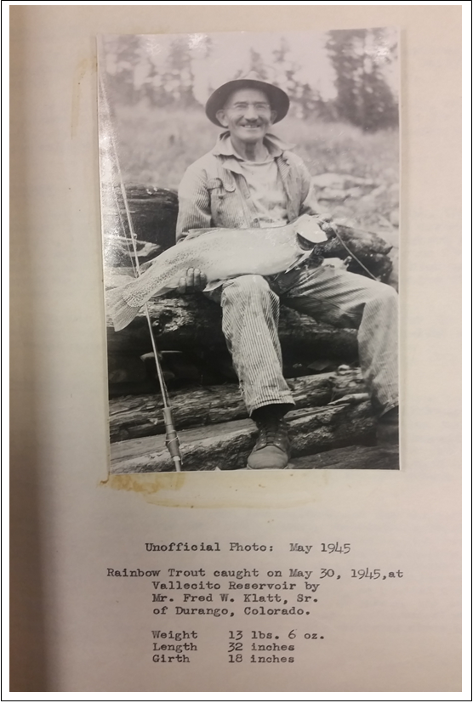
Figure 2. Fred Klatt with trophy trout from Vallecito Reservoir in 1945

Current Recreation
Vallecito Reservoir currently offers a wide variety of recreational opportunities for the public including hiking, day use, picnicking, fishing, sightseeing, bird watching, snowshoeing, cross-country skiing, and more. Recreation facilities at Vallecito Reservoir and the concessions, groups, and organizations associated with Vallecito Reservoir are described below.

Facilities
Recreation facilities at Vallecito Reservoir include the marina at Sawmill Point operated by the Vallecito Marina and Yacht Club (VMYC), picnic areas, campgrounds, trailheads, community center building, and more as further described below.
- Marina at Sawmill Point (VMYC)
  - 55 slips and 140 buoys for boat storage
  - Public courtesy dock (marina docking area)
  - Boathouse and store (fishing licenses, tackle, beverages, snacks, day use permits, memorabilia, fueling station etc.)
  - Boat ramp (40 ft wide, two-lane, ending at elevation 7,629 feet)
  - Parking area with approximately 80 parking spaces and overflow trailer parking
  - ANS inspection and decontamination station run by Colorado Parks and Wildlife
  - Restrooms and potable water outside restroom facilities
  - Covered picnic tables
- Day Use/Picnic Areas
  - Aspen Point (with vault toilet)
  - Chamber of Commerce Building/Community Center at Angler’s Warf (with vault toilet)
  - Dam Park (with vault toilet)
  - Kokanee Point (with vault toilet)
  - Marina at Sawmill Point (with restrooms)
  - Mountain Ute Park (with vault toilet)
  - Old Timers (USFS; with vault toilet)
- Campgrounds (USFS)
  - Graham Creek
  - Middle Mountain
  - North Canyon
  - Pine Point
- Trailheads
  - Lower Dam Trail
  - Lower East Lake Trail
  - Lake Eileen Trail
  - Upper East Lake Trail
  - West Lake Trail
- Chamber of Commerce Building near Angler’s Wharf
  - 30-foot by 60-foot multi-purpose room
  - 20-foot by 20-foot commercially equipped kitchen

Concessions
PRID currently works with the following recreation-based concessionaires at Vallecito Reservoir. Additional entities are encouraged to apply with PRID.

Vallecito Conservation and Sporting Association (VCSA)/Vallecito Marina and Yacht Club (VMYC)
A concessionaire contract between PRID and VCSA (and approved by Reclamation) was entered into on May 8, 2020 for operating a marina and store at Vallecito Reservoir. VCSA is a 501(c)(4) not for profit entity. The VMYC is a subsidiary of the VCSA and operates the marina at Sawmill Point.
Other recreation activities conducted by the VCSA include:
- Winter ice fishing tournament;
- Regatta and poker run (boat and small yacht racing events);
- Youth fishing tournament (each youth receives a free rod and reel);
- Youth archery course and instruction;
- Mushroom identification and foray; and
- Ice skating rink.

Groups and Organizations
PRID currently works with the following recreation affiliated groups and organizations at Vallecito Reservoir. Additional entities are encouraged to coordinate events and activities at Vallecito Reservoir with PRID.

Vallecito Nordic Club
For many years the VNC and USFS joined forces to provide winter cross-country skiing on the east side of Vallecito Reservoir. In the winter of 2016 to 2017 Reclamation initiated discussions and negotiations with the USFS to resolve recreation fee collection concerns raised by USFS. The negotiations resulted in a February 24, 2021 agreement between the USFS and Reclamation which recognized PRID’s right and authority to collect recreation fees at Vallecito Reservoir, including recreation permits for winter skiing.

Guided/Chartered Fishing
Vallecito Reservoir provides trophy game fishing opportunities for multiple fish species. At present, there are approximately three guide or charter fishing businesses operating at Vallecito Reservoir. Each has acquired a special use/commercial use permit with PRID for their guide fishing business.

Vallecito Lake Chamber of Commerce
The Vallecito Lake Chamber of Commerce has a license agreement with Reclamation to operate and maintain a Chamber of Commerce building and associated parking areas for public service and related functions near Angler’s Wharf.

Visitation Numbers and Use Patterns
Vallecito Reservoir offers year-round recreational activities including fishing, hiking, boating, camping, and general recreation in the summer and Nordic skiing and ice fishing in the winter. Peak visitation is generally in the summer as the community of Vallecito swells with tourists and secondary homeowners, however hundreds of people may recreate at Vallecito Reservoir on a busy winter weekend. Based on permits sold, PRID estimated annual visitation in 2022 to be 33,870 user days, however, visitation is known to be higher as not all recreationists at Vallecito Reservoir obtain the appropriate permit (Table 1).
Table 1. Estimated Visitation Numbers in Calendar Year 2022 Based on Permits Sold
USE | PERMITS SOLD | USE DAYS | ESTIMATE PEOPLE PER VEHICLE | TOTAL USER DAYS
Annual (estimated 10 days/permit) | 743 | 7,430 | 2 | 14,860
Two Week (estimated 14 days/permit) | 34 | 476 | 2 | 952
Daily (1 day/permit) | 8,676 | 8,676 | 2 | 17,352
Boat | 353 | 353 | 2 | 706
Total Estimated User Days |  |  |  | 33,870

Planned Recreation
PRID will engage the local community and other interested parties in future planning and development actions with an emphasis on public safety, environmental and resource protection, and balanced use of the project area. PRID is currently exploring options to extend the boat ramp at the marina by an additional 40 feet to facilitate boat launching at low water levels.

Permits and Fees

Permits
Recreation activities (group sponsored or individual participation) at Vallecito Reservoir require a PRID use permit(s) and compliance with any local, State, or Federal requirements is required. Permits may be purchased on the PRID website (see Section 11) or obtained in person at select local businesses such as the Pine River Lodge, Elk Point Lodge, and general stores. PRID issues daily, two-week, and annual permits for recreation at Vallecito Reservoir. The recreation use permit, which is displayed as a hang tag from the rear-view mirror of the permit holder’s automobile, is not a “parking permit” as may be perceived by visitors. Rather, it is a permit to recreate at Vallecito Reservoir. An additional motorized boating permit is required for all privately owned motorized boats operating on Vallecito Reservoir and is available as a daily or annual permit. In addition, all boat owners are required to comply with all Federal and State rules, regulations, and fee assessments prior to accessing the reservoir.
PRID also issues special (also called “short-term”) and commercial use permits for not-for-profit and for-profit recreation events and activities at Vallecito Reservoir. Special use permit activities may include but are not limited to social and community gatherings or activities such as weddings, church related events, educational events, holiday and birthday celebrations, reunions, and anniversaries. Commercial use activities may include but are not limited to guide services (such as fishing, hunting, and horseback riding), boat charter services, sports/fishing events, and arts and crafts fairs and product sales.
Fees associated with PRID recreation permits are detailed below.

Fees
PRID’s current (2023) recreation and user fees at Vallecito Reservoir are listed in Table 2 (below) and can also be found on the PRID website (see Section 11). Revenue from permit fees is used to sustain recreation at Vallecito Reservoir and support future recreational improvements.
Potential special and commercial use permit holders must apply to PRID (application available on PRID’s website – see Section 11) and pay a non-refundable $100.00 fee for initial review of the application. The application and nonrefundable fee must be submitted to PRID 60 days prior to the planned event/activity. Upon PRID’s (and Reclamation’s if needed) approval of a special or commercial use application, applicants are required to submit a signed and dated permit form (available on PRID’s website – see Section 11) acknowledging that all requirements and obligations outlined in the permit, including the sale of individual recreation use permits to those participating in the event/activity, will be adhered to. Potential special or commercial use permit holders must pay an additional $200.00 fee to PRID for administrative costs incurred for processing the approved application. Additionally, for commercial use permits, PRID charges a 20% fee on gross revenue generated during the commercial use permit event/activity period. Lastly, PRID will reimburse special and commercial use permit holders 10% of the revenue generated on the sale of individual recreation use permits sold for their specific event/activity.
Future fee increases will be discussed at PRID’s annual public meetings and at a public meeting specific to recreation. PRID plans to increase fees in 2024 as outlined below in Table 2.
Table 2. Current and 2024 Proposed Recreation and User Fees at Vallecito Reservoir
USER FEE | CURRENT RATE | 2024 PROPOSED RATE
Recreation Permits
Recreation Day Use Permit (Per Vehicle) | $5.00 | $6.00
Recreation Two Week Use Permit (Per Vehicle) | $25.00 | $30.00
Recreation Annual Use Permit (Per Vehicle) | $50.00 | $60.00
Motorized Boating Permits
Motorized Boating Day Use Permit | $5.00 | $6.00
Motorized Boating Annual Use Permit | $50.00 | $60.00
Special Use Permits (Not-For-Profit)
Application (Non-Refundable) | $100.00 | $100.00
Permit & Administrative Costs (After Application is Approved) | $200.00 | $200.00
Commercial Use Permits (For-Profit)
Application (Non-Refundable) | $100.00 | $100.00
Permit & Administrative Costs (After Application is Approved) | $200.00 | $200.00
Permit Gross Revenue Fee | 20% | 20%

Establishing Fee Pricing Levels for the Recreation Permits
Adjusting and setting recreation permit fees is accomplished by a comparative analysis with neighboring recreation projects (see Table 3 below) and PRID’s recreation operating costs. PRID has learned, from public input, that smaller fee increases over more frequent periods of time are generally more acceptable to the public than large fee increases over a several year period. By comparing fees with neighboring recreation projects, and historical recreation operation costs, PRID can document and recommend rate changes that are competitive with local rates and may adjust fees following public input and consideration.
Table 3. Comparison of Surrounding Recreation User Fees to Vallecito Reservoir (Per Vehicle Unless Otherwise Noted). Last Updated on March 6, 2023.
RECREATION AREA | DAILY FEE | ANNUAL FEE
Vallecito Reservoir | $5.00 | $50.00
Lake Nighthorse | $10.00 | $80.00
Navajo State Park (CO) | $10.00 | $80.00
Navajo Lake State Park (NM) | $5.00 | $40.00
Lake Capote | $5.00 | NA
Lake Farmington | $1.00 | $50.00

Rules and Regulations
PRID requests that recreation users at Vallecito Reservoir please observe the below rules as well as follow all applicable Federal (including 43 CFR Parts 420, 423, and 429), State, County, and local laws and regulations. Rules, laws, and regulations have been established to help ensure the safety and enjoyment of all visitors who recreate at Vallecito Reservoir. To enhance Vallecito Reservoir’s recreation experience and to protect and preserve our natural resources for future generations, please exercise caution, common sense, and safety while recreating.
Violations of any of the applicable rules, laws, and regulations are subject to cautions, warnings, evictions, citations/fines, prosecutions, confiscations, and where provided by law, incarcerations if deemed necessary by legal authorities.
The following rules are specific to Vallecito Reservoir or are summarized from 43 CFR Parts 420, 423, and 429 because they are particularly relevant to recreation at Vallecito Reservoir. All rule, laws, and regulations established in 43 CFR Parts 420, 423, and 429 apply regardless of if they are specifically detailed below.
- AIS/ANS: You shall follow all applicable Federal, State, and local rules and regulations pertaining to AIS/ANS and inspection and decontamination requirements.
- Boating Hazards: Water levels fluctuate at Vallecito Reservoir and potential boating hazards are always changing. Boat at your own risk. PRID does not mark hazards. Boaters should exercise common sense and stay a safe distance from the shoreline. Reduce vessel speed when operating in an unfamiliar area of the reservoir. Remember, as water levels drop, islands and other boating hazards such as tree stumps and rocks present themselves throughout the reservoir surface.
- Boat/Vessel Fueling: Boat or vessel fueling on Vallecito Reservoir is allowed at the marina at Sawmill Point. All other fueling must occur on land and at least 150 feet from the water’s edge (Vallecito Reservoir and inlet/outlet waters). Fueling boats on the reservoir can lead to gasoline spills and negatively affect water quality.
- Camping: Overnight camping (including overnight boat mooring) is prohibited on the lands and waterbody under PRID’s management (43 CFR 423.33). Camping is allowed at the USFS campgrounds on the east side of Vallecito Reservoir under USFS rules and regulations.
- Controlled Substances: You must not possess, consume, deliver, or be under the influence of, controlled substances included in schedules I, II, III, IV, or V of part B of the Controlled Substance Act (21 U.S.C. 812) on Reclamation (Vallecito Reservoir) facilities, lands, or waterbodies, unless the controlled substance was legally obtained through a valid prescription or order (43 CFR 423.44).
- Drones and model aircraft: Use of drones, other unmanned aerial vehicles, and model aircraft is prohibited except as allowed in special use areas and permitted by Reclamation. No special use areas are currently designated at Vallecito Reservoir.
- Fires and Flammable Material: Fires are allowed only in PRID provided BBQ/fire rings. Per 43 CFR 423.31:
  - You must not leave a fire unattended, and it must be completely extinguished before your departure.
  - You must not improperly dispose of lighted smoking materials, including cigarettes, cigars, pipes, matches, or other burning material.
  - You must not burn materials that produce toxic fumes, including, but not limited to tires, plastic, floatation materials, or treated wood products.
  - You must not transport gasoline and other fuels in containers not designed for that purpose.
  - You must comply with all applicable Federal, State, and local fire orders, restrictions, or permit requirements.
- Fireworks: You must not use or possess explosives, or fireworks or pyrotechnics of any type, except as allowed by a permit (43 CFR 423.30).
- Hunting, Fishing, and Trapping: You may hunt, fish and trap in accordance with applicable Federal, State, and local laws, and subject to the restrictions of 43 CFR 423.30 and 43 CFR 423.32. In addition, underwater spearfishing, archery, slingbows, and gigs are prohibited at Vallecito Reservoir one-half hour after sunset to one-half hour before sunrise.
- Interference with Agency Functions and Disorderly Conduct: You must observe the rules in 43 CFR 423.32 (listed below) which pertain to all PRID and Reclamation personnel.
  - You must not assault, threaten, disturb, resist, intimidate, impede, or interfere with any employee or agent of Federal, State, or local government engaged in an official duty.
  - You must comply with any lawful order of an authorized government employee or agent for the purpose of maintaining order and controlling public access and movement during law enforcement actions and emergency or safety-related operations.
  - You must not knowingly give a false report or other false information to an authorized government employee agent.
  - You must not interfere with, impede, or disrupt the authorized use of Reclamation facilities, lands, or waterbodies or impair the safety of any person.
  - The following acts constitute disorderly conduct and are prohibited.
    - Fighting, or threatening or violent behavior,
    - Language, utterance, gesture, display, or act that is obscene, physically threatening or menacing, or that is likely to inflict injury or incite an immediate breach of the peace;
    - Unreasonable noise, considering the nature and purpose of the person’s conduct, location, time of day or night, and other factors that would govern the conduct of a reasonable prudent person under the circumstances;
    - Creating or maintaining a hazardous or physically offensive condition; or
    - Any other act or activity that may cause or create public alarm, nuisance, or bodily harm.
- Mooring: Overnight boat mooring is allowed only at designated locations at the marina at Sawmill Point. Camping is not allowed on boats moored overnight at the marina.
- Natural and Cultural Resources: You must comply with 43 CFR 423.29 regarding natural and cultural resources at Vallecito Reservoir. Among other rules described in this CFR, you must not destroy, injure, deface, remove, search for, disturb, or alter natural resources or cultural resources, including abandoned buildings or structure, on or in Reclamation facilities, lands, or waterbodies. This includes culturally important trees that may be found throughout the project area.
- Operating Vessels on Reclamation Waters: You must comply with 43 CFR 423.38 regarding the operation of vessels on Reclamation waters (Vallecito Reservoir).
- Permits and Fees: An appropriate use permit and payment of associated fee is required for recreation activities at Vallecito Reservoir. Permits and fees are discussed in Section 8.
- Pet Refuse: All pet refuse must be disposed of properly. Pet waste stations with bags are provided by PRID throughout Vallecito Reservoir.
- Quiet Time: Quiet time at Vallecito Reservoir is between 10 p.m. and 7 a.m.
- Refusal of Services: PRID recreation staff reserves the right to refuse service and revoke all privileges pertaining to entry for any reason of misconduct, or any violation of the rules that are listed within these rules and regulations or that are posted at Vallecito Reservoir. Refunds will not be given to persons who are asked to leave Vallecito Reservoir for not following these rules and regulations.
- Restrooms: Please use the restroom facilities as provided. These include porta potties, vault toilets, and flush restroom facilities (See Figure 1 for restroom locations). Be considerate of others while you are at Vallecito Reservoir. Use restrooms for their intended purpose only. Dumping of RV and camping refuse in restroom facilities is prohibited.
- Sanitation: All litter and trash must be disposed of properly. Trash receptacles are available throughout the Vallecito Reservoir area for your use. You must comply with 43 CFR 423.34 regarding sanitation.
- Trails: All trails at Vallecito Reservoir managed by PRID are multiple use unless otherwise restricted through a special use permit. Use of e-bikes is allowed. Groomed winter ski trails on the south side of the Vallecito Reservoir are designed for skiing with separate trails established for snowshoeing and walking. Biking on groomed winter ski trails at Vallecito Reservoir is prohibited.
- Trespassing: You must not trespass on Reclamation facilities, lands, and waterbodies at Vallecito Reservoir. As described in 43 CFR 423.24 (listed below), trespass includes any of the following acts:
  - Unauthorized possession or occupancy of Reclamation facilities, lands, or waterbodies;
  - Personal entry, presence, or occupancy on or in any portion or area of Reclamation facilities, lands or waterbodies that have been closed to public use pursuant to subpart B of this part 423;
  - Unauthorized extraction or disturbance of natural or cultural resources located on Reclamation facilities, lands, or waterbodies;
  - Unauthorized conduct of commercial activities on Reclamation facilities, lands, or waterbodies;
  - Holding unauthorized public gatherings on Reclamation facilities, lands, or waterbodies; or
  - Unauthorized dumping or abandonment of personal property on Reclamation facilities, lands, or waterbodies.
- Vandalism, Tampering, and Theft: You must not vandalize, tamper with, or steal as described in 43 CFR 423.25 (listed below). Do not remove picnic tables, fire rings, or BBQs from camp sites or picnic areas.
  - You must not tamper or attempt to tamper with, move, manipulate, operate, adjust, or set in motion property not under your lawful control or possession including, but not limited to, vehicles, equipment, controls, recreational facilities, natural resources, and devices.
  - You must not destroy, injure, deface, damage, or unlawfully remove property not under your lawful control or possession.
  - You must not drop, place, throw, or roll rocks or other items inside, into, down, or from, dams, spillways, dikes, or other structures and facilities.
- Vehicles: You must follow vehicle rules as described in 43 CFR 423.40 (listed below). All off-road vehicular travel is prohibited.
  - When operating a vehicle on Reclamation lands, and Reclamation projects, you must comply with applicable Federal, State, and local laws, and with posted restrictions and regulations. Operating any vehicle through, around, or beyond a restrictive sign, recognizable barricade, fence, or traffic control barricade is prohibited.
  - You must not park a vehicle in violation of posted restrictions and regulations, or in a manner that would obstruct or impede normal or emergency traffic movement or the parking of other vehicles, create a safety hazard, or endanger any person, property, or natural feature. Vehicles so parked are subject to removal and impoundment at the owner’s expense.
  - You must not operate any vehicle, or allow another person to operate a vehicle in your control, in a careless, negligent, or reckless manner that would endanger any person, property, natural resource, or cultural resource.
  - In addition to the regulations in 43 CFR 423.40, the regulations governing off-road-vehicle use in 43 CFR Part 420 apply.
- Weapons and Firearms (including Target Practice): You must observe the rules in 43 CFR 423.30 (listed below) regarding weapons and firearms. Target practice at Vallecito Reservoir is prohibited except for operation of the youth archery course while under instruction provided by the VCSA.
  - You may possess firearms, ammunition, bows and arrows, crossbows, or other projectile firing devices on Reclamation lands and waterbodies, provided the firearm, ammunition, or other projectile firing device is stowed, transported, and/or carried in compliance with applicable Federal. State, and local law, with the following exceptions:
    - You must not have a weapon in your possession when at or in a Reclamation facility.
    - You must comply with any prohibitions or regulations applicable to weapons in a special use area established by an authorized official under subpart E of 43 CFR Part 423.
  - You must not discharge or shoot a weapon unless you are:
    - Using a firearm or other projectile firing device lawfully for hunting or fishing as allowed under 43 CFR 423.32; and
    - In compliance with applicable Federal, State, and local law.

Policies, Practices, and Procedures
PRID enjoys an excellent working relationship with Reclamation, VCSA, VMYC, VNC, landowners, and other area interests. We share a common perspective that recreation at Vallecito Reservoir is best achieved through a community minded/centered approach where recreation dollars stay in the Vallecito community area for the benefit of the community and points beyond. Every effort will be expended to continue to foster and build these partnership relationships associated with Vallecito Reservoir, and more specifically, its recreation component.
The below section highlights PRID’s key policies, practices, and procedures for recreation at Vallecito Reservoir.

Hours of Operation
PRID does not have designated hours for general recreational use at Vallecito Reservoir. Day use areas are intended for using during the day. The marina and boat ramp at Sawmill Point are open from 7 am to 7 pm generally from May through October depending on conditions.

Closures (Emergency, Seasonal, etc.)
Reclamation’s Primary Jurisdiction Area near Vallecito Dam is closed for recreation. Road 603 is seasonally closed in the winter except for some access to private inholdings and to groom ski trails. Road 603 at the east end of Vallecito Reservoir may also be closed to vehicle traffic during certain times of the year by private property owners near the 5 Branches Camper Park. PRID may implement emergency or other condition-dependent closures to Vallecito Reservoir roads and areas throughout the year as needed.

AIS/ANS Inspection and Decontamination Procedures
A new AIS/ANS inspection and decontamination station staffed by CPW is being operated at the Vallecito Reservoir marina located at Sawmill Point. Colorado is a mandatory boat inspection state meaning that all trailered and/or motorized watercraft are required to be professionally inspected by state certified personnel prior to launching in any water of the state after boating in a different state, upon exiting any water in the state which is positive for an invasive species, and any time an inspection is requested prior to entering or exiting a water body in Colorado.
PRID and its concessionaires observe all applicable Colorado rules and regulations regarding boating and AIS/ANS. Prospective boaters at Vallecito Reservoir are encouraged to review Colorado rules and regulations on these topics and visit CPW’s website for more information (see Section 11).

Regulation of Vallecito Reservoir Water Elevations and Impacts on Recreation
PRID will continue to evaluate the impacts of Vallecito Reservoir elevation on recreation activities and work with recreation partners to minimize impacts to recreation as much as possible. Per the concession contract with VCSA, “Reclamation and the District reserve the right to regulate water levels and allow fluctuations according to operational needs.”

Marina and Vallecito Reservoir Recreation Program Sustainability
PRID will not permit other marina services to occur until the VMYC has been in operation for a long enough period (three to five year minimum) to allow for the collection of marina market data necessary for a reliable and professional marina services sustainability study to be performed. In short, PRID has no desire to flirt with or repeat poor recreation service practices of the past. Instead, PRID plans to learn and incorporate knowledge gained from past events for the development of a contemporary, sustainable, and model recreation program.

Length of Time of Recreation Concession Contracts
Recreation concession contracts were historically validated for is around 25 years, However, PRID has noticed disadvantages of maintaining contracts of this length due to the slippage of contract terms and conditions over time. Consequently, PRID will generally reduce future contract life intervals to 5 to 10 years.

Annual Meetings
Prior to the end of each year PRID will hold annual meetings with Reclamation, recreation organizations, and user groups to evaluate what worked well during the year, and areas that need improvement for the coming year. These organizations and groups include the VCSA, VMYC, VNC, CPW, and AIS/ANS inspection station staff among others.
PRID, in conjunction with Reclamation, will also host an annual recreation meeting with the general public and area businesses to obtain their thoughts and input regarding meaningful and insightful ways to improve recreation opportunities at Vallecito Reservoir.

Law Enforcement
PRID, Reclamation, Southern Ute Indian Tribe, La Plata County Sheriff, La Plata County Commissioner’s Office, congressional representatives, and others have worked diligently to formulate a process for the La Plata County Sheriff’s office to provide law enforcement services at Vallecito Reservoir. Significant progress has been made. These efforts will continue until a recreation law enforcement process is developed.
Current proposed changes to 43 CFR Part 423 (Public Conduct On Bureau of Reclamation Facilities, Lands, and Waterbodies) aim to clarify the responsibilities of all to pay camping and other recreation fees where applicable when at Reclamation facilities, lands and waterbodies and whose managing partners may or may not have enforcement capabilities (such as irrigation districts). Comments on the proposed rulemaking must have been submitted on or before April 17, 2023.

Website Links
The following website links provide additional information about PRID, use permits at Vallecito Reservoir, CPW boat AIS/ANS inspection and decontamination, and Reclamation CFRs.
- PRID website: https://www.pineriverirrigationdistrict.com/
- PRID use permits: https://www.pineriverirrigationdistrict.com/use-permits-and-associated-guide-and-instructions
- CPW Boat AIS/ANS: https://cpw.state.co.us/thingstodo/Pages/boatinspection.aspx
- 43 CFR Part 420 (Off-Road Vehicle Use): https://www.ecfr.gov/current/title-43/subtitle-B/chapter-I/part-420
- 43 CFR Part 423 (Public Conduct On Bureau of Reclamation Facilities, Lands, and Waterbodies): https://www.ecfr.gov/current/title-43/subtitle-B/chapter-I/part-423
  - Proposed Revisions: https://www.govinfo.gov/content/pkg/FR-2023-02-16/pdf/2023-03151.pdf
- 43 CFR Part 429 (Use of Bureau of Reclamation Land, Facilities, and Waterbodies): https://www.ecfr.gov/current/title-43/subtitle-B/chapter-I/part-429

